TECHNICAL DEVELOPMENT PLAN

Confidentiality Statement
This document contains proprietary and confidential information that is the property of Blockchain Continuous Compliance Systems, Inc. (BCCS). It is intended solely for the recipient(s) to whom it is addressed for the purpose of evaluating the business opportunity described herein.
By accepting this document, the recipient agrees to treat all information contained within as strictly confidential and not to disclose, copy, or distribute it to any third party without prior written consent from BCCS.
All ideas, concepts, and materials presented in this document are proprietary to BCCS and are protected by applicable intellectual property laws. The recipient further agrees not to use any part of this document for any purpose other than the evaluation of this business opportunity.
If the recipient is not the intended party, they are requested to return this document to BCCS, immediately and destroy any copies in their possession.
Blockchain Continuous Compliance Systems, Inc. (BCCS) retains all rights to the content herein.

Project Overview
In parallel with the MVP build, we are developing an AI-powered Data Import Tool that will allow users to upload scanned or digital compliance documents (PDF, JPEG, PNG, XLSX, CSV) for automatic ingestion. The tool uses OCR, NLP, and confidence scoring to extract and validate structured compliance data before it is submitted to the blockchain for tamper-proof recordkeeping.
Phase One - MVP
We are building the Minimum Viable Product (MVP) for a blockchain-based compliance tracking platform called BCCS (Blockchain Continuous Compliance Systems). The system will initially serve pilot training organizations (ATO/TRTO) and their regulators by providing a shared, tamper-proof training and audit record.
We are building a development team to deliver a functional MVP within 90 days, using an agile, milestone-based approach. Preference will be given to teams with experience in blockchain (Hyperledger or Polygon PoS) and enterprise SaaS UI/UX.
MVP Core Features (Phase 1 Scope)
AI-Powered Data Import Tool: Supports CSV, PDF, image-based, and spreadsheet uploads. Uses OCR and NLP to extract fields such as Student, License Number, Event Type, and Date. Users validate data in a side-by-side UI. Validated records are saved and queued for blockchain logging.
Immutable Training Event Logging
Save training events immutably on private blockchain
Fields: Student, Event Type, Instructor, Date, Status, Certificate Upload
Compliance Dashboard
Role-based access: ATO Admin, Instructor, Auditor, Regulator
Visual indicators for overdue items, training gaps
Export to CSV/PDF
Web-based User Interface
Login flows for ATO Admins and Read-Only Regulator views
Mobile-friendly design (responsive)
Pilot Client Onboarding Portal
Upload training records via CSV
Invite users and assign roles
Audit Trail and Activity Logging
Full logging of actions (viewed, edited, signed) with timestamps
Security
2FA login
Encrypted data (at rest and in transit)
Role-based data segregation
Tech Stack Preferences
AI Data Ingestion Tool
- OCR: AWS Textract or Tesseract
- NLP: HuggingFace Transformers or spaCy
- ML Storage: MongoDB (intermediate processing)
- Final DB: PostgreSQL (MVP aligned)
- Frontend: React with Tailwind
- Hosting: AWS or GCP
Frontend: React (Next.js optional)
Backend: Node.js / Express
Blockchain: Hyperledger Fabric (preferred) or Polygon PoS
Database: PostgreSQL or equivalent
DevOps: Docker, CI/CD (GitHub Actions or similar)

Deliverables
- AI-powered document import and validation tool integrated into the BCCS dashboard
- OCR/NLP model training pipeline and user correction feedback loop
- Logging and export of user ingestion actions for audit trail inclusion
Fully functional MVP deployed to a staging environment
Codebase and documentation (GitHub repo)
Admin panel for ATO operations
Training log smart contracts (optional Phase 1.5 stretch)
User and onboarding documentation
Testing report and known issues list
Timeline
Duration: 90 calendar days
Milestones: Weekly sprints + 3 major demos (Day 30, 60, 90)

Technical Specification – BCCS AI-Powered Data Import Tool
Project Summary
Develop a web-based, AI-powered data import tool for Blockchain Continuous Compliance Systems (BCCS) to help users ingest scanned or digital compliance records (e.g., PDFs, spreadsheets). The tool should automate data extraction and offer a user-friendly validation interface. This MVP enables BCCS to prove core value, generate user feedback, and onboard pilot clients for case studies, testimonials, and early revenue while preparing for a more comprehensive launch.
Core Functional Requirements
1. File Upload Interface
Functionality:
Drag-and-drop and manual file upload
Supported formats: .pdf, .jpeg, .png, .xlsx, .csv
File Status States:
Uploaded → Processing → Ready to Validate → Validated
2. OCR & NLP Processing Pipeline
OCR:
Use Tesseract or AWS Textract
Extract text from scanned images or PDFs
NLP:
Use spaCy or HuggingFace Transformers for named entity recognition
Field mapping for: Name, License #, Expiration Date, Training Event, etc.
3. Machine Learning Confidence Scoring
Assign confidence score (0–100%) to each extracted field
Highlight low-confidence fields in the UI
Capture user corrections to retrain models (feedback loop)
4. Validation UI
Side-by-Side Interface:
Left pane: Preview of original document
Right pane: Extracted and editable fields
Actions:
Approve, Edit, Flag
Save validated record to database
5. Audit Logging
Log all user actions:
Upload, Edit, Approve, Flag
Time-stamped and user-attributed
Store event logs for future audits
6. Output Formatting & Blockchain Integration
Structure validated data in BCCS-compliant JSON schema
Queue for blockchain submission (Phase 2 integration)
Planned Enhancements (Post-MVP):
- Continuous training of ML models using real-time user correction data
- API-based integration with client HR and training management systems
- Regulatory-grade blockchain submission workflows
- Expansion to support additional document formats and languages
Suggested Tech Stack
Team Roles
Success Metrics
90%+ of fields auto-filled correctly
<30% of files require manual correction
<10 minutes average user import time
Development Milestones
Week | Milestone Description
---- | ---------------------
1–2 | Import Tool frontend prototype (upload + preview)
3–4 | Backend document processing pipeline and confidence scoring
5–6 | Validation UI integration with MVP dashboard
7–8 | Audit logging and import testing with sample partner data
9 | Full workflow test: Import → Validation → Blockchain logging
10 | Deployment and onboarding toolkit

MVP – Compliance Handshake Summary
Core MVP Features (Phase 1 – 90-Day Build Scope)
Immutable Event Logging (Blockchain Ledger)
Capture and store key compliance-related events (e.g., training completion, maintenance task, inspection)
Each event is timestamped, assigned a unique ID, and saved immutably to a private blockchain ledger (Hyperledger or similar)
Fields: Entity (person or tail number), Event Type, Date, Status, Document/Note upload, Logged By
Basic Compliance Dashboard
Role-based access: Admin, Operator, Auditor, Viewer
View compliance status by asset (aircraft) or person (pilot/mechanic)
Visual indicators for overdue or upcoming compliance items
Export function (CSV or PDF)
User Interface (Web-First)
Web-based login portal
User dashboard with recent activity, compliance alerts, and record summaries
Mobile-friendly/responsive design
Pilot Client Onboarding Portal
Invite pilot clients via secure email
Upload user and asset data manually or via template (CSV import)
Help resources (short tutorial or PDF guide)
Audit Trail and Activity Log
View log of who added, edited, or viewed entries (with timestamps)
Internal-only for now; used to demonstrate traceability
Security Layer
Encrypted data at rest and in transit
2FA login (email + OTP)
Basic user management controls
Optional Stretch Features (Phase 1.5)
Regulator Read-Only View: Allows external auditor to verify compliance records
Email Notifications: Compliance alerts to responsible users
API Hook (v1): One endpoint to pull compliance status for a given aircraft or crew
Pilot Client Value Proposition
Real-time, tamper-proof compliance logs
Reduced audit prep time
Visibility across training and aircraft assets
Early adopter pricing and roadmap influence
Limitations of MVP (Transparent to Clients)
Limited integrations (manual data entry/import only)
No mobile app yet
Limited analytics (focus is recordkeeping, not forecasting)
Not yet regulator-certified (advisory use only)
Build Strategy
Outsourced development using agile sprint cycles (3–4 devs max)
MVP ready in 90 days with biweekly demos and feedback from founding clients
Development stack: React or Next.js frontend, Node.js or Django backend, private permissioned blockchain (e.g., Hyperledger Fabric, Polygon PoS private chain)

MVP – Expanded User Stories, Flowchart, and Dashboard Wireframes

USER STORIES – FLIGHT SCHOOL (MVP)

Admin (BCCS)
- As an Admin, I want to create flight school accounts, so I can onboard clients onto the BCCS platform.
- As an Admin, I want to configure compliance modules based on the flight school type and regulatory requirements, so the dashboard reflects accurate audit metrics.
- As an Admin, I want to assign user roles (Instructor, Compliance Officer, Manager), so access is properly restricted and functional.
- As an Admin, I want to track system-wide metrics (usage, data imports, errors), so I can manage platform health and performance.

Flight School Staff
- As a Training Admin, I want to upload student records using drag-and-drop or CSV, so I can digitize our historical training documentation.
- As a Compliance Officer, I want to see a real-time dashboard with overdue or non-compliant records highlighted, so I can intervene proactively.
- As an Instructor, I want to receive alerts for training actions (e.g., checkrides expiring), so I can notify students in time.
- As a Manager, I want to generate compliance reports in PDF or CSV format, so I can share data with regulators or internal auditors.
- As a User, I want to review and correct AI-imported data, so that only accurate entries are committed to the blockchain.

Regulator (Read-Only MVP)
- As a Regulator, I want to log in securely to review a flight school’s compliance dashboard, so I can verify that training records are in order.
- As a Regulator, I want to view immutable logs of submitted training events, so I can confirm authenticity.
- As a Regulator, I want to export snapshots or reports of a flight school’s current status, so I can archive evidence of periodic reviews.

EXPANDED MVP FLOWCHART – FLIGHT SCHOOL ONLY
1. Admin (BCCS)
- Create Flight School Account
- Assign Modules & Permissions
- Monitor Usage
2. Flight School
- Upload Records (CSV, PDF, JPG)
- OCR/NLP AI Processes Fields
- User Validates Fields
- Approve / Edit / Flag
- Confidence Score Displayed
- Record Logged (DB + Blockchain)
- Dashboard Displays Compliance Status
3. Regulator (Read-Only)
- Secure Login
- Access Compliance Dashboard
- Review Immutable Records
- Export Summary Report

DASHBOARD WIREFRAMES – MVP (TEXTUAL DESCRIPTION)

1. Flight School Dashboard (Main User View)
Top Section:
- Current Compliance Score
- Alerts: "3 records overdue", "2 certificates expiring in 10 days"
Main Table:
- Rows: Each training event
- Columns: Student Name, Event Type, Date, Status, Certificate, AI Confidence
- Actions: Edit | Validate | View History
Sidebar Widgets:
- Upload New Record
- Import Status (e.g., "5 files pending validation")
- Quick Export (PDF/CSV)

2. Admin Panel (BCCS)
Client Overview:
- List of Active Flight Schools
- Last Login, Last Upload
System Metrics:
- Total Files Processed
- Validation Success Rate
- Blockchain Submission Queue
Controls:
- Add New Client
- Manage Feature Flags
- Assign Test Clients

3. Regulator Dashboard
Compliance Snapshot:
- % of Compliant Training Events
- Breakdown by Event Type (Checkride, Ground, Simulator)
Audit Trail Viewer:
- View immutable logs with timestamp, user, action
Quick Access:
- School Dropdown
- Export Current View
- Filter by Compliance Status

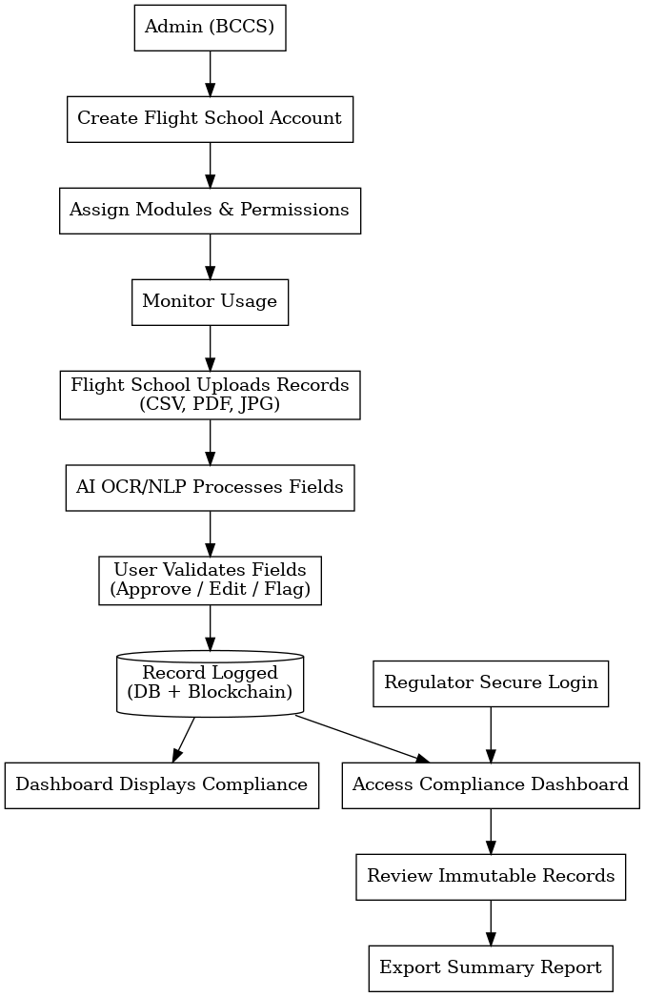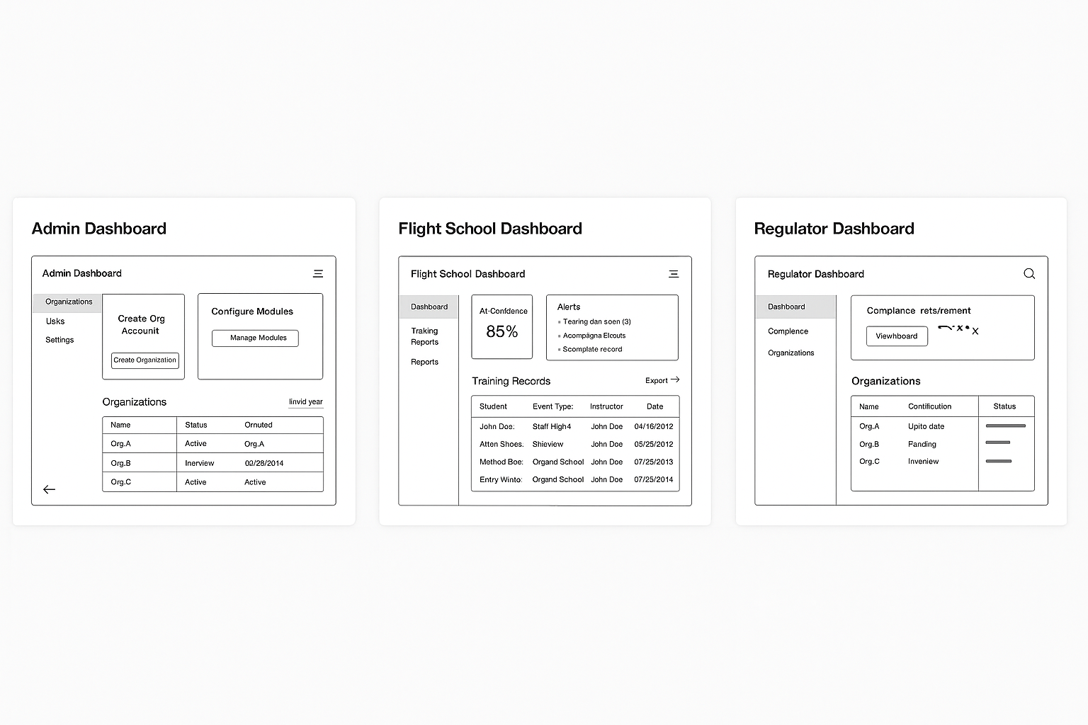

MVP Scope Recap
- Immutable training event logging (blockchain backend)
- AI-powered data import (OCR + NLP)
- Validation interface (React frontend)
- Compliance dashboard (role-based views, alerts)
- Security (2FA, audit logging, encryption)

Minimum Team Composition

1. Full-Stack Developer (1 person) – Core Lead
- Focus: React frontend, Node.js backend, PostgreSQL, REST APIs
- Why: Can build the user interface, business logic, CSV importer, and basic admin dashboard.
- Learn-on-the-job: Can also handle light blockchain integration via SDKs and work with templated smart contracts.
- Proficient in JavaScript/TypeScript, Node.js, React, RESTful APIs
- Familiar with relational databases like PostgreSQL
- Comfortable with DevOps basics (Docker, CI/CD, GitHub Actions)

2. Blockchain + DevOps Engineer (1 person, part-time or contractor)
- Focus: Set up Hyperledger Fabric or Polygon PoS private network, smart contract templates, Docker, and staging environment.
- Why: This is a technical trap for newcomers; outsourcing setup ensures reliable, secure infrastructure in weeks instead of months.
- Effort: < 20–30% time after setup

3. AI/NLP Engineer (1 person, part-time or contractor)
- Focus: OCR (Tesseract or AWS Textract), NLP (spaCy or HuggingFace), confidence scoring, basic AI pipeline
- Why: Getting structured data from analog records is the key value of BCCS. This should not be left to guesswork.
- Effort: Build pipeline once; refine with feedback

